Tab Run/Cost Audit Request

This form should be used to request Tab Run/Cost Audit reports from Conduent. (NOTE: You may need to Enable Macros/ActiveX for this form to work correctly. If you have this functionality disabled, a Security Warning bar will appear above.)
Please fill in the following information and submit your request via email to ABQOPS@Conduent.com. Once your request has been processed, the Tab Run/Cost Audit reports will be available in .pdf files on the New Mexico Web Portal.
If you have any questions, please send an email to the address identified above.

Required Information for Request
Requestor
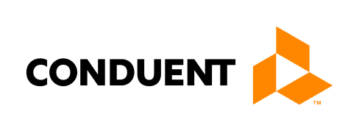
Please enter your Medicaid ID: Enter ID.
Type of Reports Requested
Service Date Range
From Date: Click to enter a date. |  | To Date: Click to enter a date.
Paid Date Range
From Date: Click to enter a date. |  | To Date: Click to enter a date.
Requested ID(s)
Please list the Medicaid ID(s) of the provider(s) for whom you want Tab Run/Cost Audit Reports:
Click here to enter text. | Click here to enter text. |  | Click here to enter text.
Click here to enter text. | Click here to enter text. |  | Click here to enter text.
Click here to enter text. | Click here to enter text. |  | Click here to enter text.
Click here to enter text. | Click here to enter text. |  | Click here to enter text.
Click here to enter text. | Click here to enter text. |  | Click here to enter text.

Complete and submit to ABQOPS@Conduent.com

